Mono Lake User Manual

- Mono Lake Block Diagram
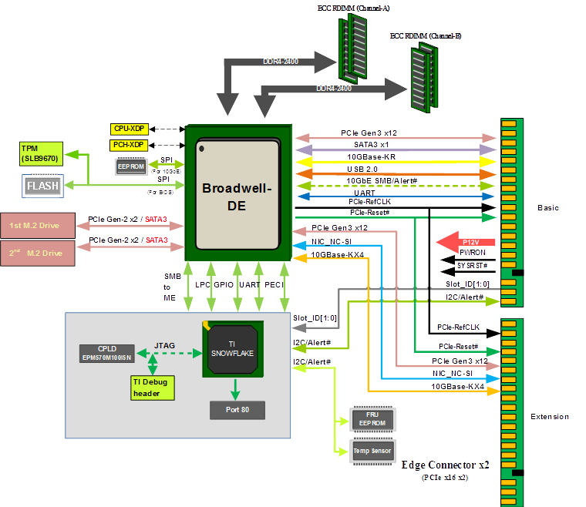

- Major components location
Top side:
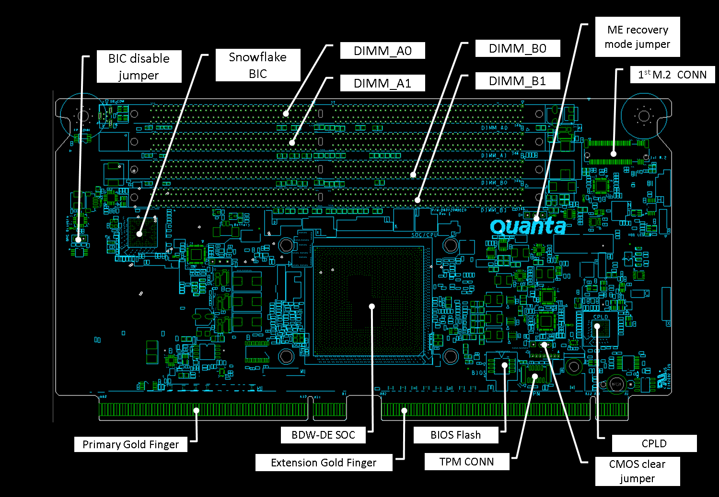

Bottom side:
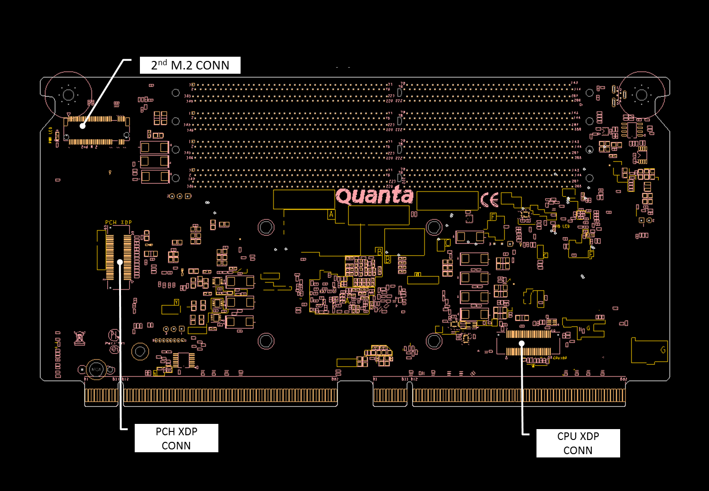
- Recommended DIMMs and M.2 SSDs
Recommended DDR4 DIMMs:
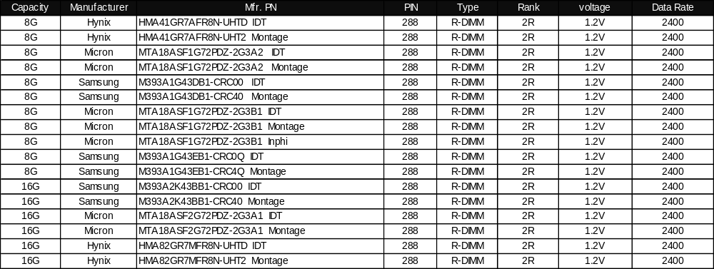

Recommended M.2 SSD:
